# CS 255 System Design Document – Cristian Alvarez

## UML Diagrams

### UML Use Case Diagram

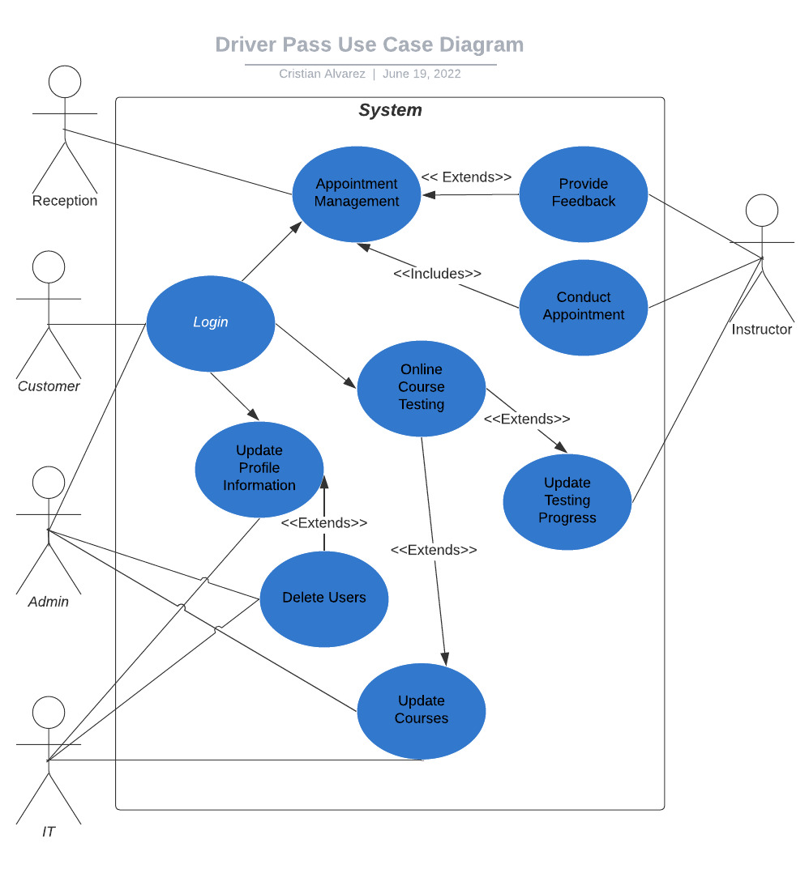

### UML Activity Diagrams

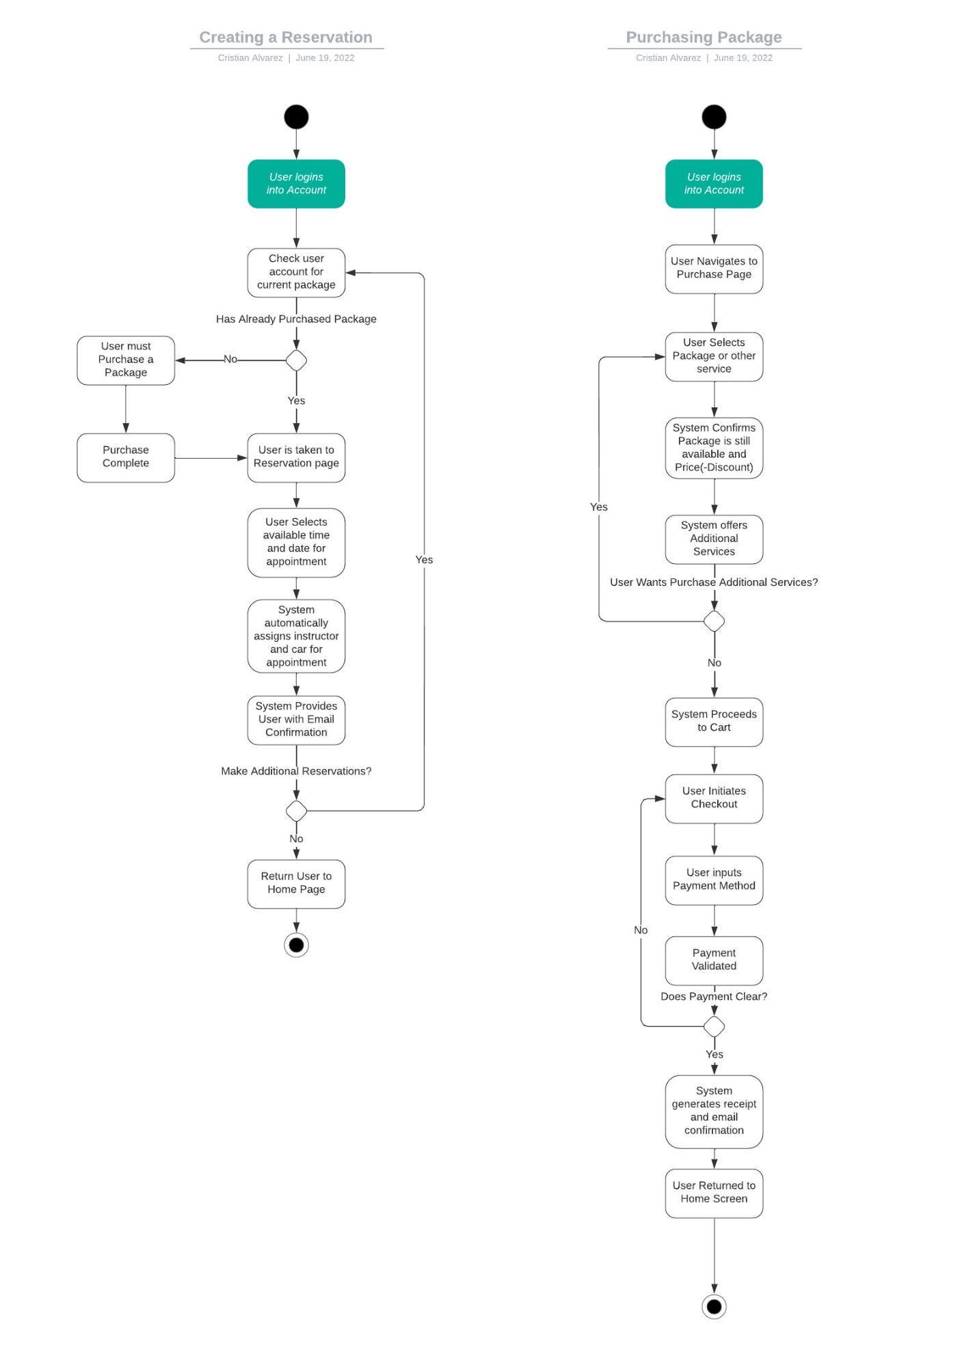

### UML Sequence Diagram

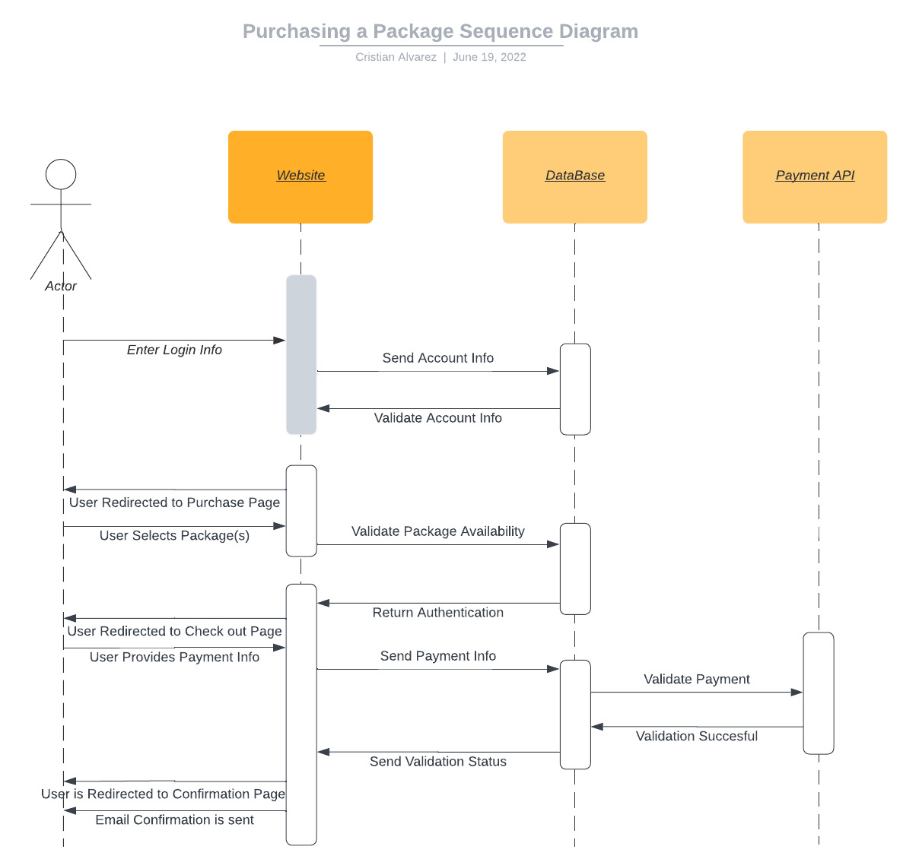

### UML Class Diagram

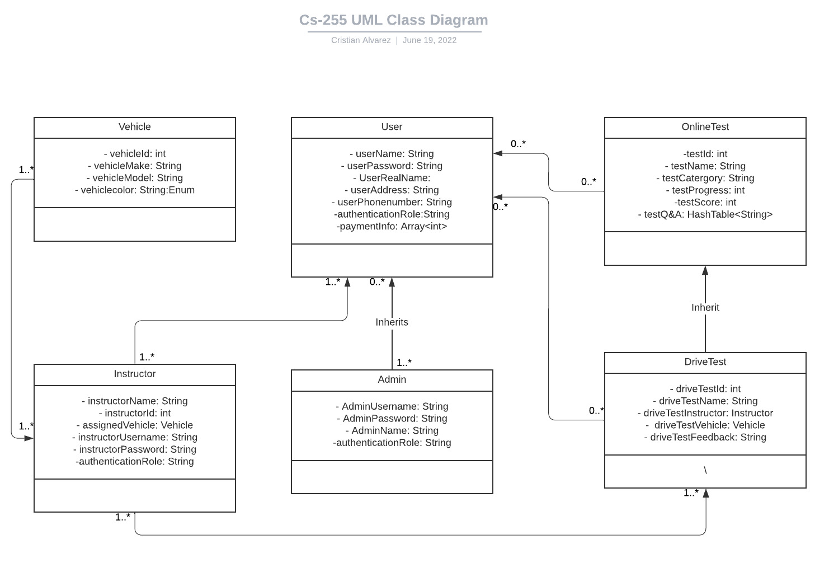

## Technical Requirements

This system will require a website to interface with the user, database and payment processing API. A Server-client design paradigm will be used to ensure users can only make requests to the server but not change information within the database unless they have the specific roles and permissions. Using a online server provide like Amazon web service will reduce upfront cost of hardware and will make easier to scale up as the business grows, while also providing great reliability for the service. This website will require either a mobile device or desktop computer that is up to date and able to display JavaScript and html formatting. The Front end will be written in JavaScript/TypeScript, HTML and CSS while the backend would be written Java to ensure multiplatform compatibility with spring boot integration. Preferably the server could be set up in SQL.